**Imports, Reading Data, and Plotting Function for Set-Up**

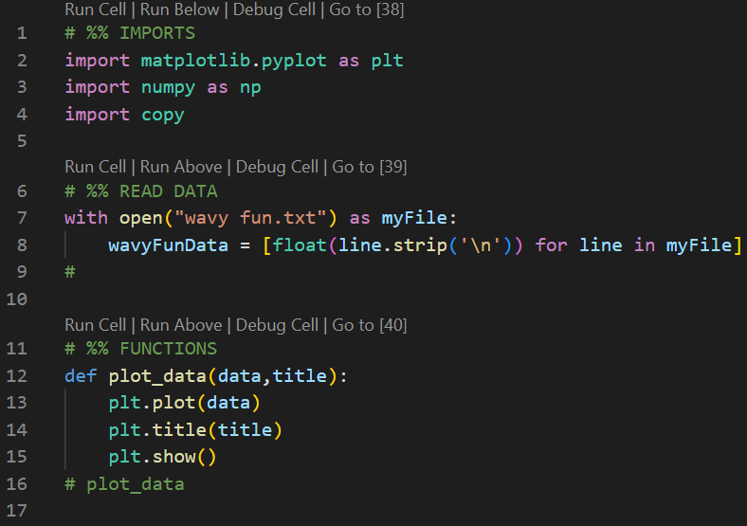

1. **Plot the Data & Output**

1. **Finding Outliers via Observation**

There is a lot of noise over the span of the graph but particularly large outliers in the 25-75 and 225 – 275 ranges.

1. **Smoothing via Standard Deviation**

1. **Smoothing via Sliding Windows – Simple & Weighted Averages**

1. **Error for Sliding Windows & Original Function**

According to the error calculations, using more neighboring points allows for not only a smoother function but also less error. However, using more neighboring points does have its limitations. The simple average seems to have less error on average when the window size remains around 7 points versus 9 points. Using weighted average, the opposite seems to be true where using 9 neighboring points lessens the error on average while still smoothing the function. **The best technique for this data set in terms of error and overall smoothness would be the sliding window with window size 7 using simple average.**